CHORLEY AND PRESTON HOSPITALS: Please contact St Joseph's Chorley (262713) if any member of your family is admitted into Chorley Hospital and needs a visit. Please ask the ward staff to call the Chaplain on his bleep/phone. For the chaplaincy service at Royal Preston Hospital please ring 01772 522435. For the chaplaincy service at Wigan Infirmary T. 01942 822324.

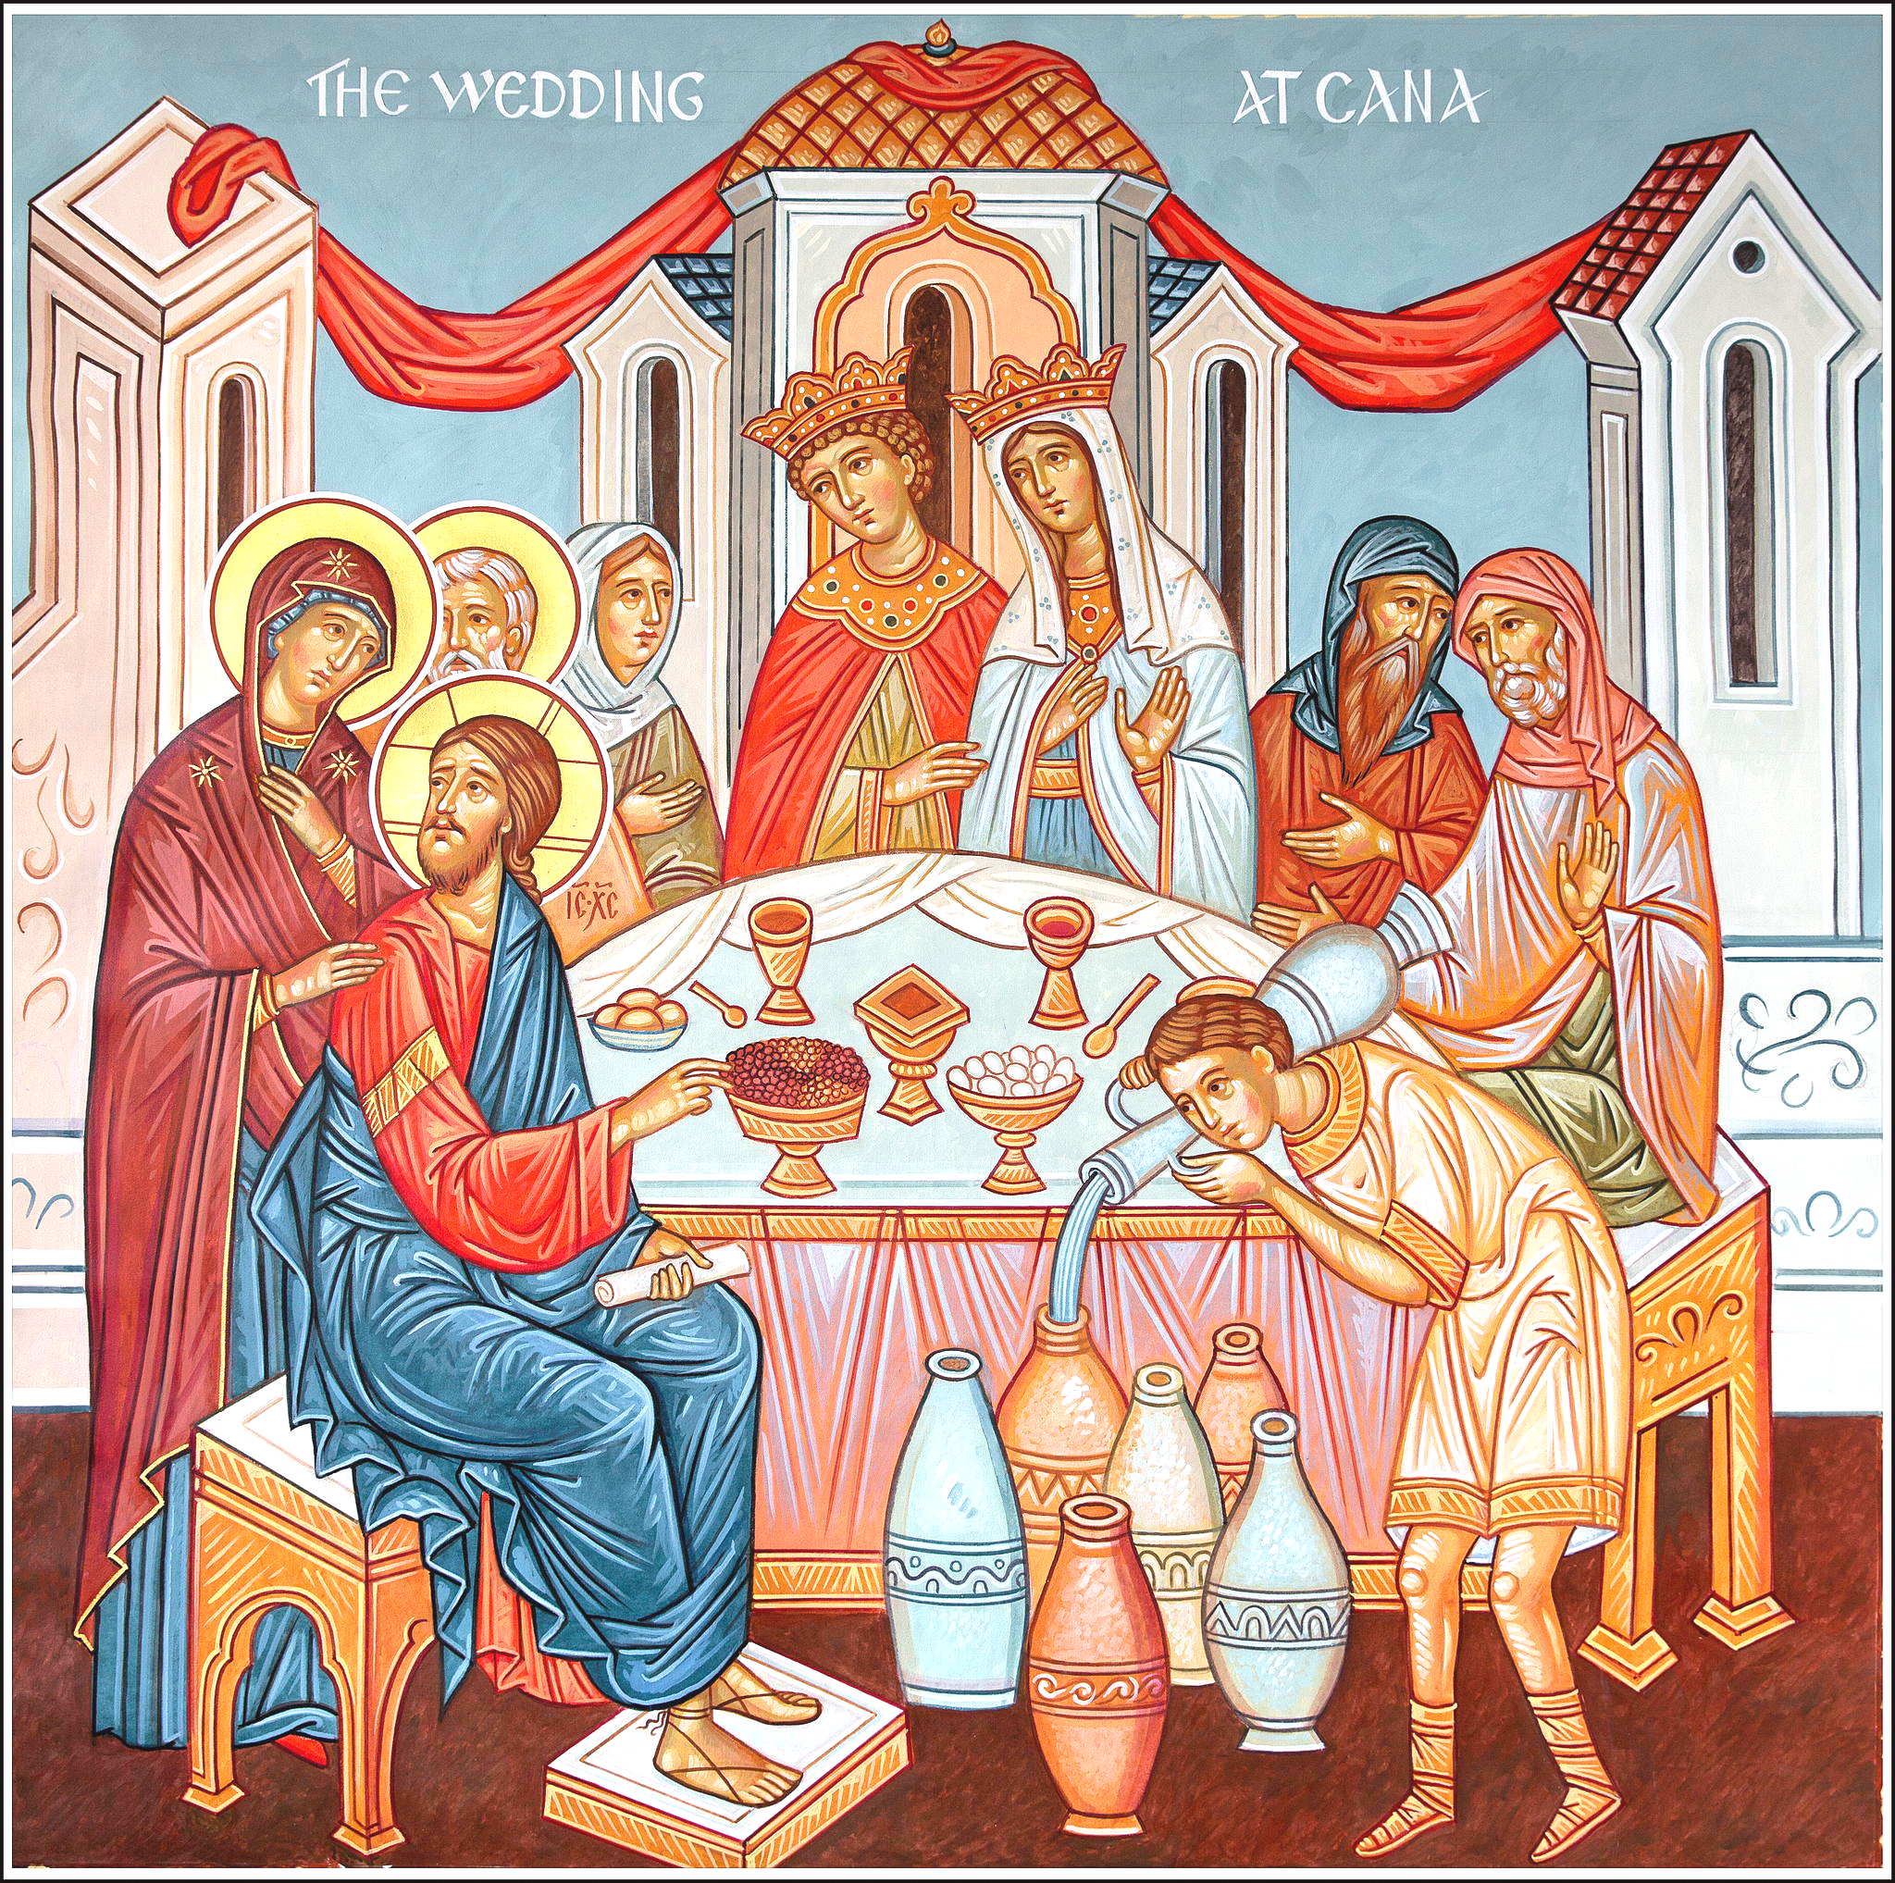
HEALTH AND SAFETY UPDATE: As you are no doubt aware, cases of COVID/Omicron have gone out of control in the nation at large and in Chorley, endangering millions of people already in poor health, who need to shield, and stretching the NHS beyond breaking point. The infections in Chorley hit a maximum of 3066 in 7 days, but they have declined slightly to 2610 in the seven days up to Jan 8th. Please continue to be very careful.
Inside church, masks must legally be worn (unless exempt – evidence must be shown), hands gelled, keep 2 metres physical distancing. We want to keep everyone safe in the church. Please take care and do not mingle with other people unless they have had a very recent negative Lateral Flow Test. If you have a runny nose, sore throat, headaches, or are generally unwell, it would be wise to take a COVID Test. Baptisms are postponed until the pandemic subsides.
Do not come to church if you have a cold or are unwell. Thank you. Holy Mass will be kept short to minimize the risk of infection. Hunker down, avoid crowded places and limit physical contacts. We want to keep ourselves and our loved ones safe. Protect the NHS by keeping safe and having your vaccines and booster. But remember they are not 100% effective; they do not make you invulnerable.

ANNUAL COLLECTION FOR LEPER CLINIC IN MUTEMWA, ZIMBABWE: The John Bradburne Clinic is growing and there are more adults and children depending on care, medicines and treatments for various illnesses including the major problem of leprosy - now known as Hansen’s Disease - The donations we raise, go towards the basic running expenses, salaries of workers, additional food and medication required by the Mutemwa Community. Brother Raymond who is lay Franciscan, is the Administrator for Mutemwa, whilst Father Linous is in charge of the spiritual well-being of the entire community at Mutemwa. This annual collection takes place next Sunday on 23rd January. Please use the Gift Aid envelopes in your boxes. More information is available from the John Bradburne Memorial Society. Thank you for your generosity.

WOULD YOU like to have a party for the Queen’s Platinum Jubilee? Please let the parish office know. Thank you.

HOLOCAUST MEMORIAL SERVICE will be held on Saturday 22nd January at 11.00 at The War Memorial in Astley Park, Chorley. Please try to physically distance and wear masks. Thank you. Lest we Forget.

Parish Priest: Fr. Francis Marsden
Deacon Norman Arrowsmith

Tel: 01257 262537

E-mail: stmaryschorley@yahoo.co.uk
Parish website: www.stmarys-chorley.org
Parish Office: Tues – Fri 10.30-13.00. 14.00–17.00

Parish Centre: 270122 or 07377 341969 (Manager – Heather Cheyne)

LIVERPOOL ROMAN CATHOLIC ARCHDIOCESAN TRUSTEES INC. Registered Charity No. 232709
St Mary’s Catholic Church, Chorley

SECOND SUNDAY OF ORDINARY TIME

16th JANUARY 2022

There was a wedding at Cana in Galilee. The mother of Jesus was there, and Jesus and his disciples had also been invited. When they ran out of wine, since the wine provided for the wedding was all finished, the mother of Jesus said to him, ‘They have no wine.’ Jesus said ‘Woman, why turn to me? My hour has not come yet.’ His mother said to the servants, ‘Do whatever he tells you.’ There were six stone water jars standing there, meant for the ablutions that are customary among the Jews: each could hold twenty or thirty gallons. Jesus said to the servants, ‘Fill the jars with water’, and they filled them to the brim. ‘Draw some out now’ he told them ‘And take it to the steward.’ They did this; the steward tasted the water, and it had turned into wine. Having no idea where it came from – only the servants who had drawn the water knew – the steward called the bridegroom and said, ‘People generally serve the best wine first, and keep the cheaper sort till the guests have had plenty to drink; but you have kept the best wine till now.’
This was the first of the signs given by Jesus: it was given at Cana in Galilee. He let his glory be seen, and his disciples believed in him. John 2:1-11

Sat 15th
16.15–45 Confessions (at porch of presbytery
17.00 Mass – Kevin McCarrick (A)

Sun 16th SECOND SUNDAY OF ORDINARY TIME (p.120 Mass book)
10.00 Mass – Sr Anne-Marie Newsham SCMM RIP
11.30 Mass at St Joseph’s Anderton

Mon 17th St Anthony, Abbot
12.00 Mass – Michael Carus (A)

Tues 18th Octave of Prayer for the Unity of Christians begins
12.00 Mass – Roland Anderton RIP

Wed 19th St Wulfstan
12.00 Mass – Daphne, Jack, Keith and Nick Smith RIP

Thurs 20th St Fabian and St Sebastian
09.00 Mass – Private Intention

Fri 21st St Agnes
12.00 Mass – Clarice Blakemore (A)

Sat 22nd St Vincent of Zaragoza
11.00 Holocaust Memorial Service in Astley Park
16.15–45 Confessions (at porch of presbytery
17.00 Mass – Barbara (A), Sr Marie and Leonard Green

Sun 23rd THIRD SUNDAY OF ORDINARY TIME
10.00 Mass – Lauren Owen (birthday remembrance)
11.30 Mass at St Joseph’s Anderton

Exposition of the Blessed Sacrament Tues, Wed and Fri. 12.30 - 13.00

Please pray for the sick and the housebound: Fr Barry McAllister, Fr Laurence Mayne, Emily Atkins, Kevin Bailey, John Brown, John and Margaret Brown, Brigid Cain, Tom Carmichael, Michael Collins, Hughie Daly, Colette Ellis, Yvonne Finlayson, Desmond Gorman, Julie Gruszka, Jacob Hughes, Rosemary Hough, Debbie MacFarlane, Teresa O’Malia, Molly Redhead, Caroline Rigby, Sr Magdalene Roskell, Denis Smith, Joan Smith, Eileen Snape, Terry Tingey, Bridget Trimm, Alan Willetts, Mike White, Ann Woodruff, Agnes Young and parishioners in The Adelphi, The Gables, Westwood, Gillibrand Hall

There are several parishioners who are very poorly after contracting COVID – Omicron. Please pray for the sick and for those who care for them. Thank you.

RECENTLY DECEASED: Kevin Mulhall (81) who died in Bolton Hospital on 28th December 2021. The Funeral Service will be at Charnock Richard Crematorium on 28th January at 15.30. Daphne Smith (97) who died on 2nd January and was a long-standing parishioner of St Mary’s. The funeral was on Thursday 13th January in Chorley. Eternal rest grant unto them, O Lord….

ANNIVERSARIES: John Cowdall, Fr Fred Matthews SMM, Fr Tom Cullinan, Barbara Green, Clarice Blakemore,

READERS: Sat: 15th 17.00 Eileen McCarrick. Sun: 16th 10.00 Tracy O’Neill. Sat: 22nd 17.00 Richard Gillett. Sun: 23rd Dr Jane Eccles.

WE ARE NOW BACK IN ORDINARY TIME in the Church’s Calendar. Traditionally, after the Holy Gospel in The Epiphany Mass, a proclamation was sung announcing the date for Easter. [2022] Know, dear brethren (brothers and sisters), that, as we have rejoiced at the Nativity of our Lord Jesus Christ, so by leave of God's mercy we announce to you also the joy of his Resurrection, who is our Saviour. On the 2nd day of March will fall Ash Wednesday, and the beginning of the fast of the most sacred Lenten season. On the 17th day of April, you will celebrate with joy Easter Day, the Paschal feast of our Lord Jesus Christ. On the 26th day of May will be the Ascension of our Lord Jesus Christ. On the 5th day of June, the feast of Pentecost. On the 19th day of June, the feast of the Most Holy Body and Blood of Christ. On the 27th day of November, the First Sunday of the Advent of our Lord Jesus Christ, to whom is honour and glory for ever and ever. Amen.
The story of the WEDDING FEAST OF CANA shows God’s blessing upon marriage, raising a natural institution to the level of a Holy Sacrament. Archbishop Fulton J. Sheen thought that it is very likely that it was one of Mary's relatives who was being married. This would mean Mary and her relatives would be embarrassed if they appeared inhospitable by running out of wine, giving Mary a reason to ask Jesus to intervene. Sheen further suggests that as Jesus arrived with additional guests (hard-drinking fishermen?), they may have contributed to the wines running short.
The gospel account of Jesus being invited to a wedding, attending, and using his divine power to save the celebrations from disaster are taken as evidence of his approval for marriage and earthly celebrations. It has also been used as an argument against the Puritanical teetotalism practised among certain sects.
The quantity and quality of wine Jesus produced is a sign of God’s immense generosity. The stone jars held 20-30 gallons of water. Say they averaged 25 gallons each. 6 x 25 gallon jars = 681 litres = 908 normal 75 cl bottles! At a Jewish wedding the bride and groom did not go away on honeymoon. They kept open house in the village for seven days, while all their relatives, friends, villagers, and well wishers came (with their presents, appropriate to the giver’s status!) to visit, and expected some refreshments! Sixth-century Irish missionary, Saint Columba of Iona, supposedly performed an identical miracle when he served as a deacon in Ireland under Finnian of Moville, replenishing the supply of sacramental wine for a Mass.
“God creates the vine and teaches it to draw up water by its roots and, with the aid of the sun, to turn that water into a juice which will ferment and take on certain qualities. Thus every year, from Noah’s time till ours, God turns water into wine. That, men fail to see. Either like the Pagans they refer the process to some finite spirit, Bacchus or Dionysus: or else, like the moderns, they attribute real and ultimate causality to the chemical and other material phenomena which are all that our senses can discover in it. But when Christ at Cana makes water into wine, the mask is off’ (John 5:19). The miracle has only half its effect if it only convinces us that Christ is God: it will have its full effect if whenever we see a vineyard or drink a glass of wine we remember that here works He who sat at the wedding party in Cana.” - C.S. Lewis, “Miracles,” God in the Dock
“The Christian does not think God will love us because we are good, but that God will make us good because He loves us.” ― C.S. Lewis
“A man can no more diminish God's glory by refusing to worship Him than a lunatic can put out the sun by scribbling the word 'darkness' on the walls of his cell.” ― C.S. Lewis, The Problem of Pain
“If we find ourselves with a desire that nothing in this world can satisfy, the most probable explanation is that we were made for another world.” ― C.S. Lewis

