CHORLEY AND PRESTON HOSPITALS: Please contact St Joseph's Chorley (262713) if any member of your family is admitted into Chorley Hospital and needs a visit. Please, by making a request for the visit, make sure that the ward staff understand that you would like the RC Chaplain to come and administer the Sacraments to your loved one, the ward staff will call the Chaplain on his bleep/phone. For the chaplaincy service at Royal Preston Hospital please ring 01772 522435. For the chaplaincy service at Wigan Infirmary T. 01942 822324.

APPEAL FROM CHORLEY BUDDIES
Chorley Catholic Community Network, Chorley Buddies, Chorley United Reformed Church and St Laurence’s, with the support of Chorley Council, are working with the Chorley Repair Café to try to help eradicate Digital Poverty in Chorley.
From Ash Wednesday onwards, we need your surplus laptops or tablets so that we can give them to the children who desperately need them. All personal data will be erased and all COVID safety measures will be in place before the devices are redistributed. Please bring your surplus tablets and laptops to
- The Presbytery at St Gregory’s Chorley
- Your Catholic Primary School, (please check with the school first)
- Massa’s Café Dessert Bar, 3 Cunliffe St, Chorley PR7 2BA
- Frederick’s Ice Cream Parlour, Bolton Road, Chorley PR7 4AL
- Inspire The Youth Zone
- St Laurence’s Rectory, Rectory Close, PR7 1QW
- Or email chorleybuddies@hotmail.com to arrange pick up.
CAROD FAMILY FAST DAY IS ON FRI 26TH. We are invited to pray, fast and give to help people like Abdella, who lives in a remote, mountainous region of Ethiopia. It takes him ten hours a day, walking to and fro to collect water. “I am wasting my life,” he says. “I am a young man. I ought to be doing something else.” Your gifts will help vulnerable communities around the world to have access to clean water – something we take for granted in England. Text LENT 10 to 70460 to give £10 (enough for sturdy water containers to store clean water safely) Or add the amount you’d like to donate eg Text LENT 5 to give £5 or LENT 20 to give £20.
Some parishioners are taking part in the WALK FOR WATER CHALLENGE - Are you ready to change your life and transform someone else’s this Lent? Sign up now on walk.cafod.org.uk Walk for Water is the only Lent challenge you need: 10,000 steps a day - done your way. Every day. For 40 days. Go the distance this Lent and help to end water poverty.
HOLY FATHER’S PRAYER INTENTION FOR FEBRUARY
We pray for women who are victims of violence, that they may be protected by society and have their sufferings considered and heeded

Parish Priest: Fr. Francis Marsden
Deacon Norman Arrowsmith

Tel: 01257 262537
E-mail: stmaryschorley@yahoo.co.uk
Parish website: www.stmarys-chorley.org

Parish Office: 11.00 -13.00, 14.00 -17.00 Tues – Fri. ONLY

LIVERPOOL ROMAN CATHOLIC ARCHDIOCESAN TRUSTEES INC. Registered Charity No. 232709
St Mary’s Catholic Church, Chorley

FIRST SUNDAY OF LENT

21st FEBRUARY 2021

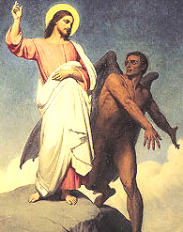
The Spirit drove Jesus out into the wilderness and he remained there for forty days, and was tempted by Satan. He was with the wild beasts, and the angels looked after him.
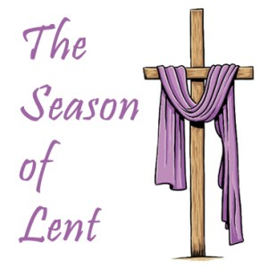
After John had been arrested, Jesus went into Galilee. There he proclaimed the Good News from God. ‘The time has come’ he said ‘and the kingdom of God is close at hand. Repent, and believe the Good News.’ Mark 1:12-15

Sat 20th
17.00 Mass –Walmsley, McNally, Ince, Calderbank, & Baxter families (RIP)

Sun 21st FIRST SUNDAY OF LENT, St Robert Southwell, SJ,
09.15 – 09.45 Confessions in the house porch
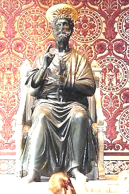
10.00 Mass – Parishioners
11.30 Mass at St Joseph’s Anderton

Mon 22nd Chair of St Peter
10.00 Mass at St Joseph’s Anderton

Tues 23rd St Polycarp, St Milburga
12.00 Mass – Patsy McCrory (A)

Wed 24th St Ethelbert of Kent
12.00 Mass – Peggy Murray (LD)

Thurs 25th Private Mass

Fri 26th CAFOD Family Fast Day
11.30 Stations of the Cross.
12.00 Mass – John Harrison (LD)

Sat 27th St Anne Line
17.00 Mass – Norah Carter (A)

Sun 28th SECOND SUNDAY OF LENT
09.15 – 09.45 Confessions in the house porch
10.00 Mass – Helen Gardner (LD)
11.30 Mass at St Joseph’s Anderton

Exposition of the Most Blessed Sacrament 12.30-13.00 Tues., Wed., Fri.

WRAP UP WARM. THE CHURCH DOORS MUST REMAIN FULLY OPEN

Newsletters and newspapers are available in the plastic box in the outdoor porch, or inside the foyer. Also, you can find sympathy cards etc in the plastic box. Catholic newspapers are at the back of the church in the normal place. Please support the Catholic papers, they are very informative and a good read.
Please pray for the sick and the housebound: Fr Dunstan Harrington, Fr Laurence Mayne, Emily Atkins, Kevin Bailey, Brigid Cain, Michael Collins, John Cullinan, Hughie Daly, Kathleen Durkin, Colette Ellis, Elmo, Paul Eastham, Yvonne Finlayson, Desmond Gorman, baby Hope, Jacob Hughes, Anne Knowles, Edward Lacey, Debbie MacFarlane, Paul McBeth, William Morris, Teresa O’Malia, Paulina Pikula, Molly Redhead, Canon Bert Shaw, Eileen Snape, Mgr. Jan Szponar, Terry Tingey, Bridget Trimm, Muriel Wilson, Ann Woodruff, Agnes Young and parishioners in The Adelphi, The Gables, Westwood, Gillibrand Hall.

ANNIVERSARIES: Patsy McCrory, Norah Carter.

READERS: Sat: 20th 5pm. Kinga Grzeczynska. Sun: 10am Tracy O’Neill. Sat: 27th Gillian Sharples. Sun: 28th Tracy O’Neill.
Please read from the Ambo by the Baptismal Font. Readings will be provided for you.
Please note that the Readers’ Rota is suspended until the COVID situation improves.

LOCKDOWN: We are open and operational for the good of all Christians in Chorley. Please observe the H&S requirements. Thank you.
Sacrament of the Sick: If you need to receive the Sacrament, please phone the Parish Office, and make an appointment. You will be seen as soon as possible.

HEALTH & SAFETY: Please note that although many of the older parishioners (70+) have been vaccinated against the Coronavirus, this does NOT make you immune. Please don’t gather in groups outside the church unless you are in a bubble. It is unsafe to do so if you do not maintain the at least two metres rule. Thank you.

Thought for Week 1 of Lent
“Remember that you are never alone. Christ is with you on your journey every day of your lives!”
Sometimes we feel distant from God, and prayer becomes a major effort. We don’t receive any spiritual consolations, feel God close to us, or hear His voice. It seems as if He is silent, and perhaps He is, for a time. But that doesn’t mean He has abandoned us. Every moment of our lives is precious to God, and we must persevere in fidelity to Him during the times He chooses to sleep in us. Our love for Him must not be contingent upon our current feelings or the goods we expect to receive, but on the knowledge of who He is, Love itself. (St John Paul II)

STATIONS OF THE CROSS each Friday of Lent at 11.30. Please go to your place and stay in your place during Stations of the Cross. There will NOT be any procession around the church for Stations this year. Also, there will NOT be Evening Prayer and Stations on Friday evenings during Lent.

LENTEN ALMS can be found by St Anthony’s statue. Thank you.

ROSARY ON SUNDAYS IN LENT we are asked to pray the Sorrowful Mysteries on Sundays during Lent.

POPE FRANCIS’ LENTEN MESSAGE
As Christians pray, fast and give alms during Lent, they also should consider giving a smile and offering a kind word to people feeling alone or frightened because of the coronavirus pandemic, Pope Francis said. “Love rejoices in seeing others grow. Hence it suffers when others are anguished, lonely, sick, homeless, despised or in need,” the Pope wrote in his message for Lent 2021.
The message, released by the Vatican Feb. 12, focuses on Lent as “a time for renewing faith, hope and love” through the traditional practices of prayer, fasting and almsgiving. And by going to confession.
Throughout the message, Pope Francis emphasized how the Lenten practices not only promote individual conversion, but also should have an impact on others.
“By receiving forgiveness in the sacrament that lies at the heart of our process of conversion, we in turn can spread forgiveness to others,” he said. “Having received forgiveness ourselves, we can offer it through our willingness to enter into attentive dialogue with others and to give comfort to those experiencing sorrow and pain.”
For example, he prayed that during Lent Catholics would be “increasingly concerned with ‘speaking words of comfort, strength, consolation and encouragement, and not words that demean, sadden, anger or show scorn.'”
“In order to give hope to others, it is sometimes enough simply to be kind, to be ‘willing to set everything else aside in order to show interest, to give the gift of a smile, to speak a word of encouragement, to listen amid general indifference,'” he said.
The Lenten practices of fasting, almsgiving and prayer were preached by Jesus and continue to help believers experience and express conversion, the pope wrote.
“The path of poverty and self-denial” through fasting, “concern and loving care for the poor” through almsgiving and “childlike dialogue with the Father” through prayer, he said, “make it possible for us to live lives of sincere faith, living hope and effective charity.”
Pope Francis emphasized the importance of fasting “as a form of self-denial” to rediscover one’s total dependence on God and to open one’s heart to the poor.
“Fasting involves being freed from all that weighs us down — like consumerism or an excess of information, whether true or false — in order to open the doors of our hearts to the one who comes to us, poor in all things, yet full of grace and truth: the son of God our savior.”
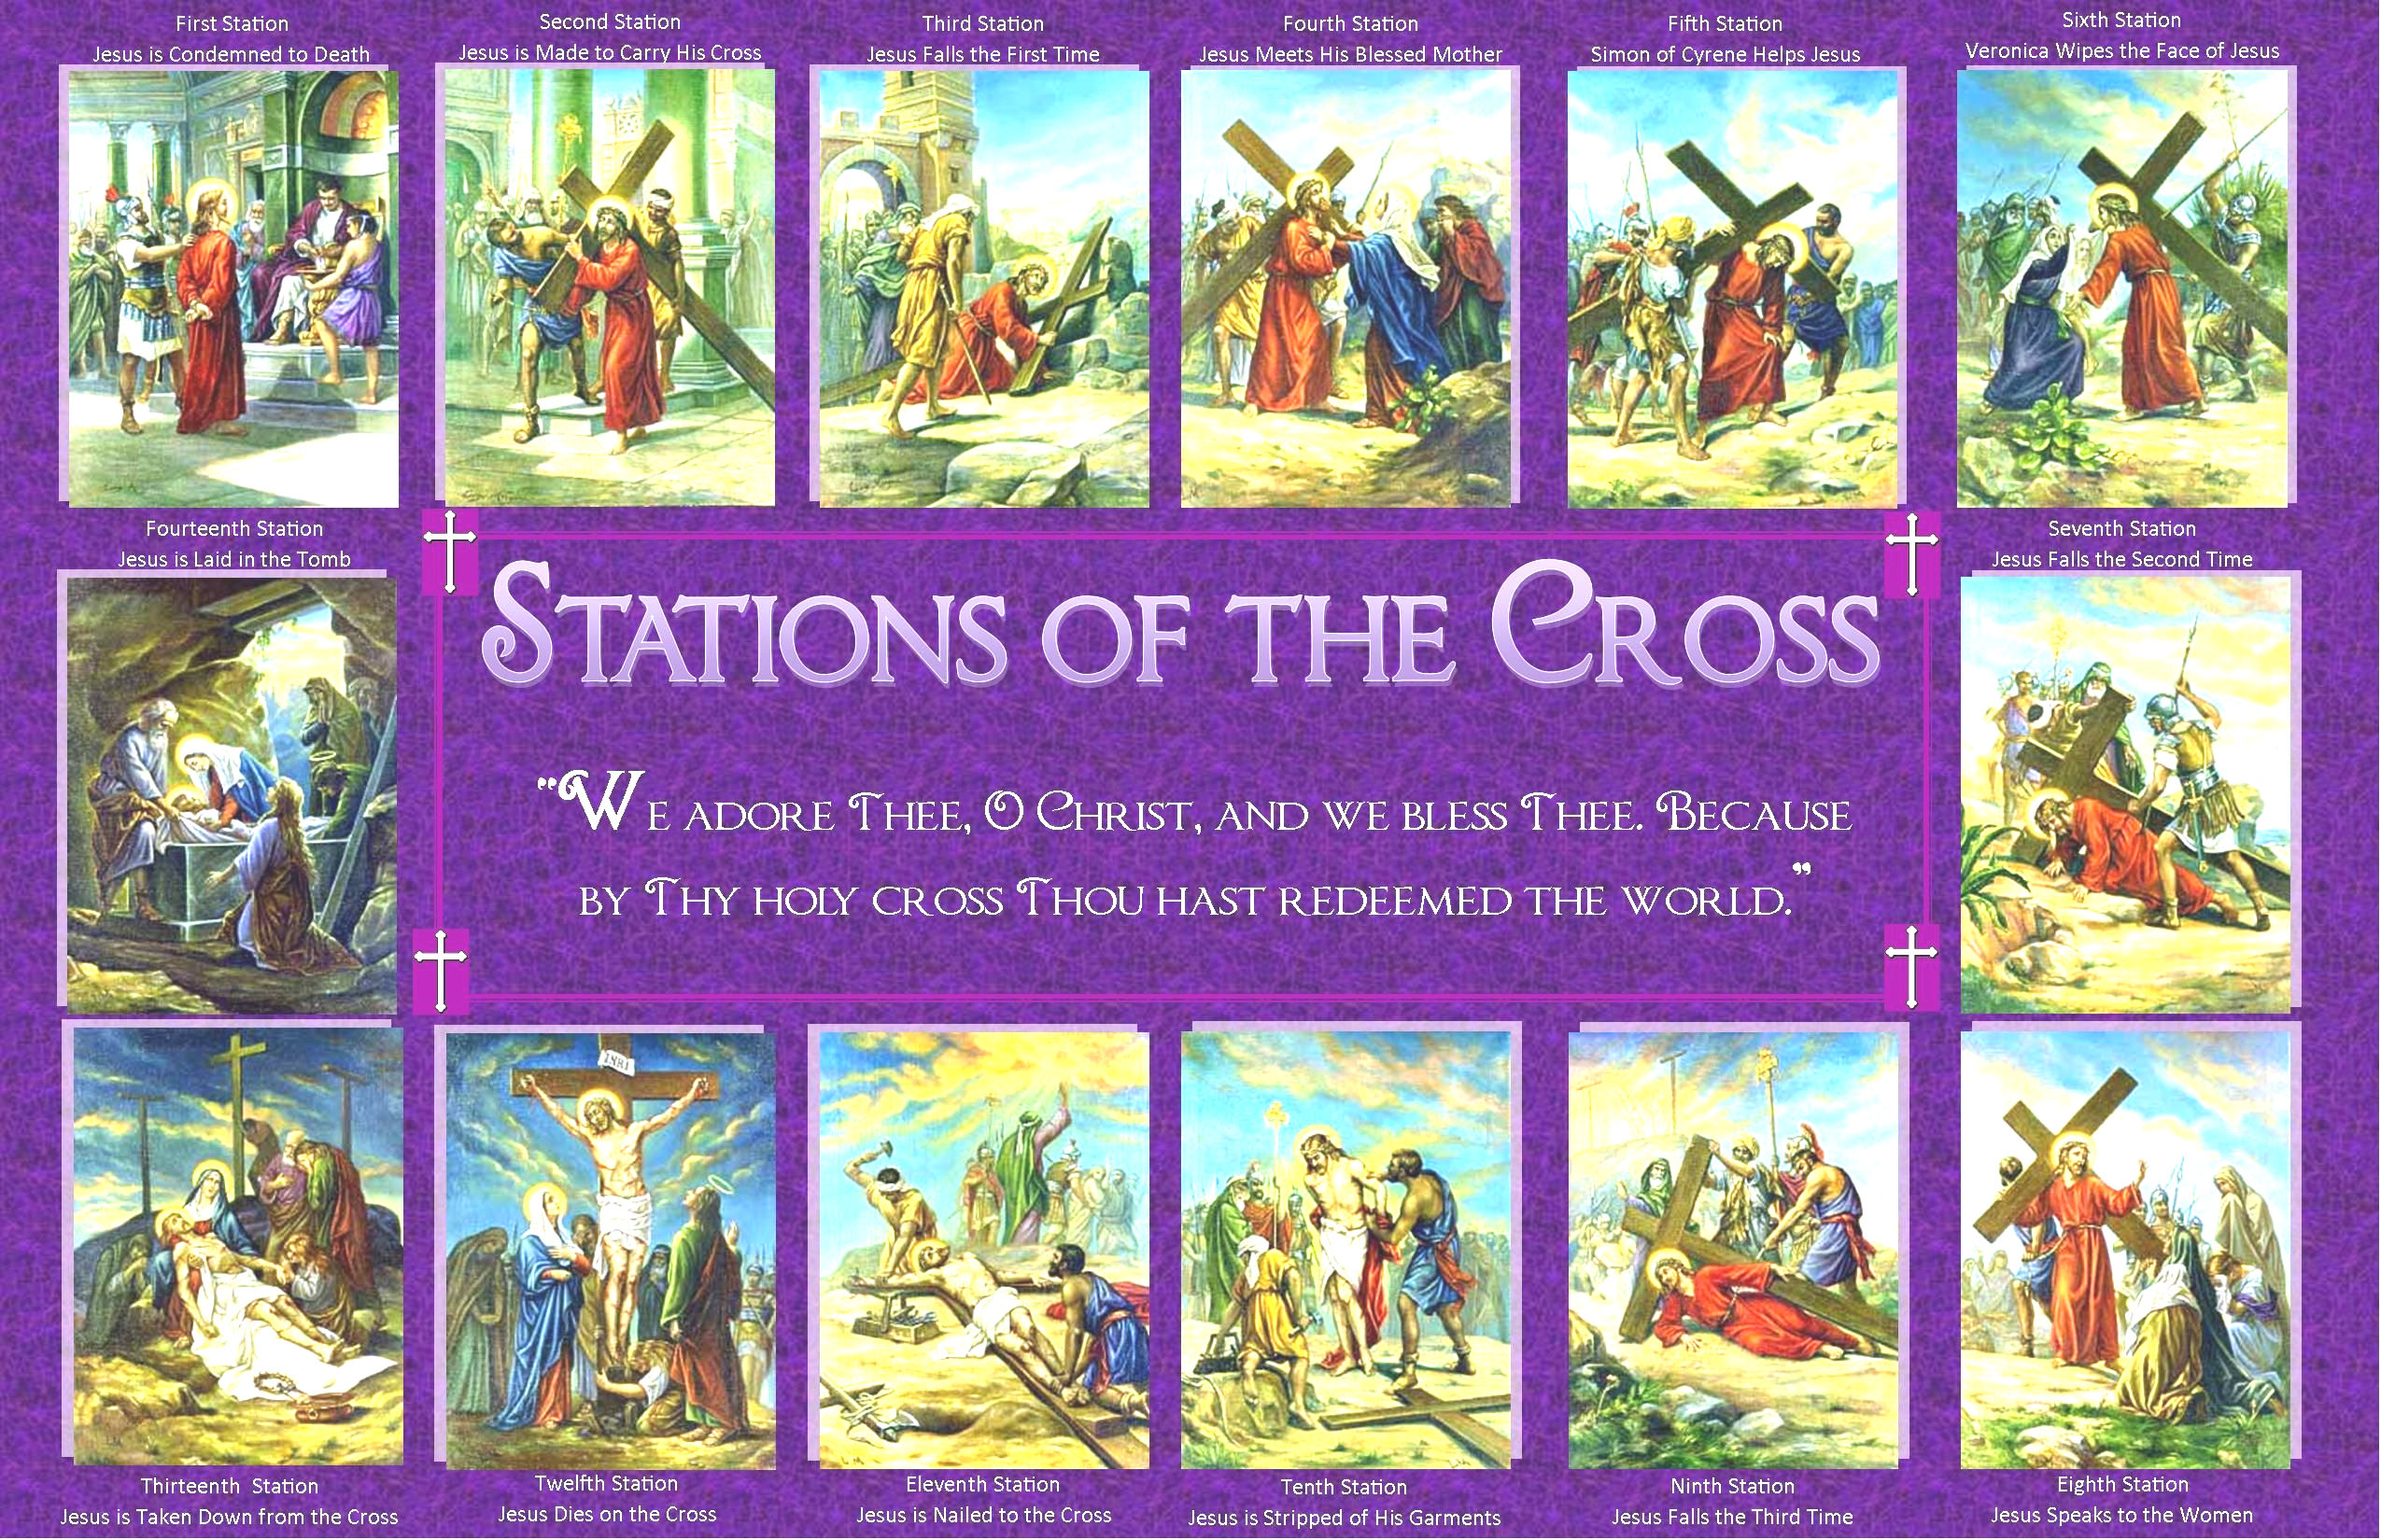
Cardinal Peter Turkson, presenting the message at a news conference, also insisted on the importance of “fasting and all forms of abstinence,” for example, by giving up “time watching TV so we can go to church, pray or say a rosary. It is only through self-denial that we discipline ourselves to be able to take the gaze off ourselves and to recognize the other, reckon with his needs and thus create access to benefits and goods for people,” ensuring respect for their dignity and rights.
Because of the COVID-19 pandemic, Lent is a time for Christians “to walk the way with Christ toward a new life and a new world, toward a new trust in God and in the future.”

